Approved by E. O. Smirnova,
Director,
Irina Viner-Usmanova’s Rhythmic Gymnastics Centre

OFFICIAL INVITATION & DIRECTIVES

Training Camps at Irina Viner-Usmanova’s
Rhythmic Gymnastics Centre

- Goals & Objectives

- Promotion of international sport exchange on amateur and professional levels
- Rhythmic gymnasts’ mastery upgrades and progress
- General and special physical training
- Healthy lifestyle
- Mastering and upgrades of R. G. apparatus skills
- Creativity, unconventional way of thinking, musicality, plasticity and artistry by means of classic and modern choreography
- Choreography, various dance styles and plasticity to be learned by young gymnasts
- Selection of talented and promising gymnasts

- Dates & Venue

27 October – 05 November 2018
26.10.2018 – arrival, check-in
27.10.2018 – 1st day of the training camp
05.11.2018 – final day of the training camp
05.11.2018 – departure day

Address: 15 Olympiyskaya Str., Novogorsk District, Khimki, Moscow Region, Russia

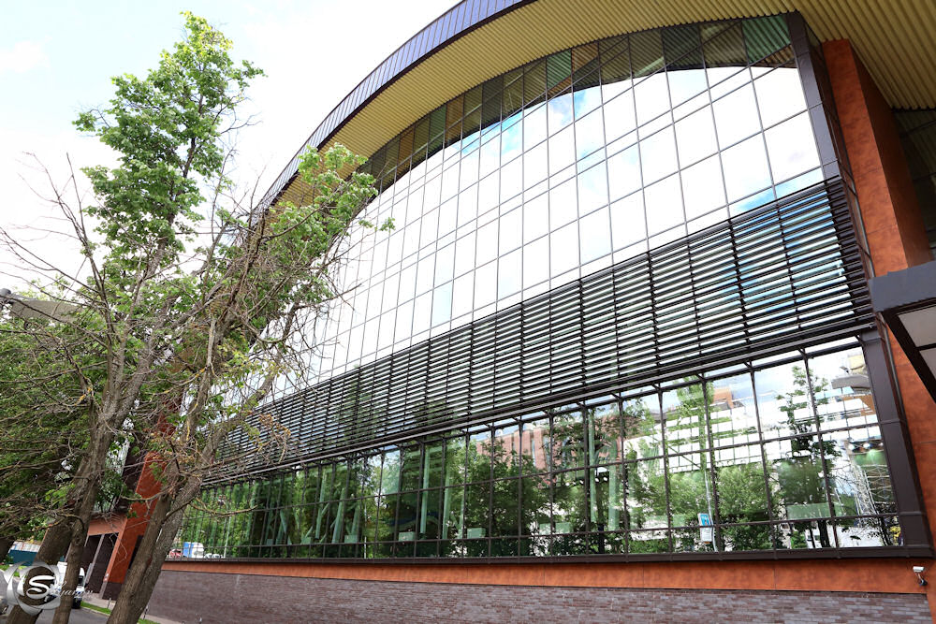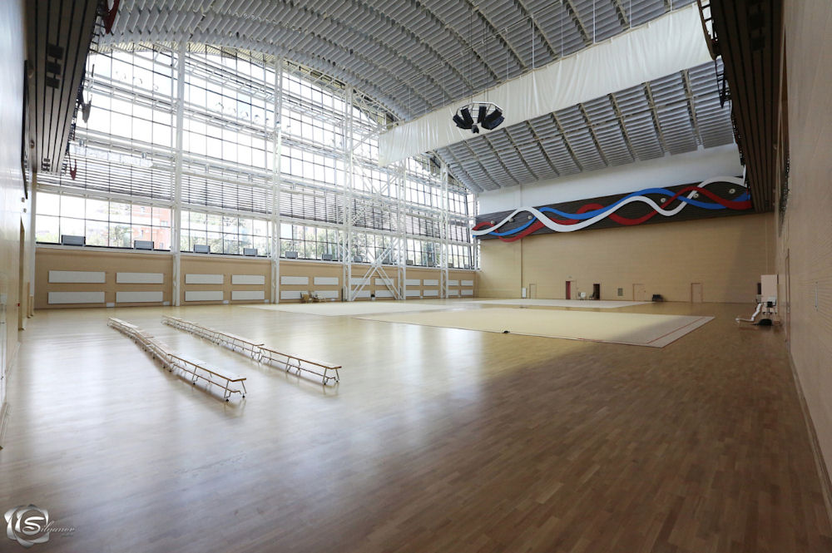
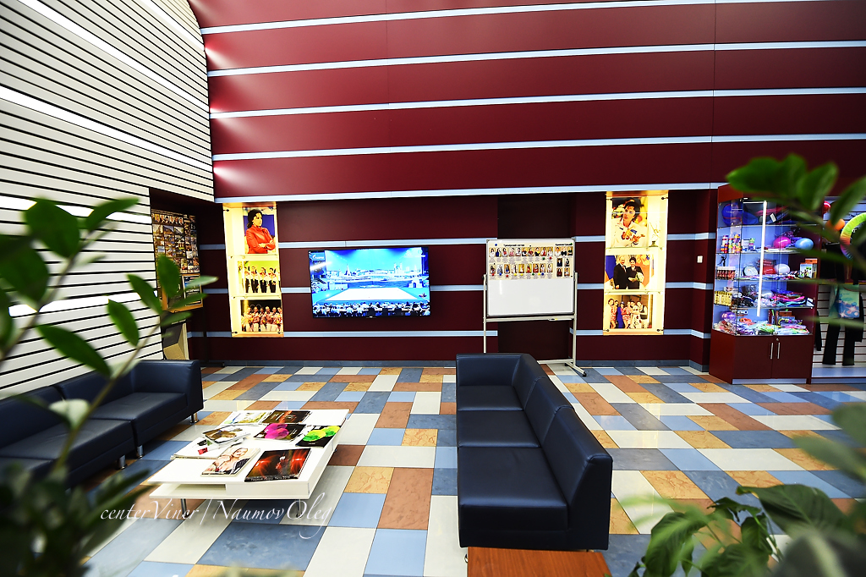

- Coaches (subject to change)

Elena Nefedova – Hon. Coach of Russia, personal coach of the sisters Olga and Ekaterina Kapranova, International Category Judge of the Russian National Team, UEG RG TC Member

Yana Arintseva – Hon. Coach of Russia, National Group Coach, Olympic Coach

Ksenia Dudkina – Hon. Master of Sport, Olympic Champion, Youth Olympic Champion, two-time World and European Champion, three-time Winner of the World Universiade (groups)

Evgenia Gertzikova – Intl. Master of Sport, two-time European Champion, Medalist of the World Championships, National Category Judge

Nina Kolesnikova – Master of Sport, Winner of multiple National RG Events

Valeria Shkred – Master of Sport, Winner of multiple National RG Events

Maria Titova – Intl. Master of Sport, Winner of multiple major National & International RG Events

Daria Dubova – Intl. Master of Sport, two-time European Champion, Youth Olympic Champion ‘2014, Winner of the World Cup and Grand Prix Events (groups)

Daria Avtonomova – Intl. Master of Sport, member of Russian National Team, World and European Champion, Winner of the World Universiade
Olga Nazarova – Hon. Coach of Russia, the first coach of Alexandra Soldatova & Ekaterina Selezneva

Daria Anenkova – Intl. Master of Sport, two-time Youth Olympic Champion

Daria Kleshcheva – Hon. Master of Sport, Winner of the European Games, World Champion in Groups All-around, member of Russian National Team

Olesya Petrova – Intl. Master of Sport, European Champion in team and apparatus events, Champion of Russia, member of Russian National Team

Karina Katiukhina – Master of Sport, Winner and Medalist of mult. International and National Events, member of Russian National Team

Oleg Antonov – Intl. Master of Sport, five-time Champion of Russia in individual and team events, mult. Winner and Medalist of South Moscow Championships

Dmitry Stepanchikov – graduate of GITIS and L. A. Arts School, Medalist of L. A. World Dance, participant in N. Y. C. Broadway Shows

Victoria Ilyina – Intl. Master of Sport, Youth Olympic Champion, two times European Champion, Winner of mult. World Cup & Grand Prix Events (groups)

Ekaterina Ermakova – Choreographer of Irina Viner-Usmanova’s Rhythmic Gymnastics Centre, Top Level Ballet Artist

Ekaterina Ivanova – Master of Sport, Winner of Mult. National and International Events, National RG Judge

Alina Tikhonova – Master of Sport, Winner of Mult. National Events

Ekaterina Uksusnikova – Choreographer of Irina Viner-Usmanova’s Rhythmic Gymnastics Centre, Top Level Ballet Instructor

Dina Yuldasheva – Choreographer of Irina Viner-Usmanova’s Rhythmic Gymnastics Centre, Top Level Ballet Artist & Instructor

- Program

Two 3-hrs training sessions daily:

- Choreography
- Apparatus Handling
- Professional Warm-up, General Physical Training
- Stretching & Flexibility
- Dancing Classes
- Acrobatics
- Optional: Making Up Routines, Individual Trainings

- Invited Participants

Gymnasts born in 2012 and older, students of youth sport schools, members of sport clubs, amateur teams, etc., with no medical restrictions that may prevent them from rhythmic gymnastics trainings.

All participants will be divided into age groups and subgroups according to their level (max. 15 gymnasts per group). Each gymnast will be paid much attention, so the total number of participants is limited. Our task is to meet highest standards of training camps!

- Participation Terms

All gymnasts must have the following:

- Birth Certificate
- Medical / Health / Incident Insurance Policy (copy)
- Doctor’s Approval for Rhythmic Gymnastics Practice
- Gymnastic Leotards, Bandages, etc.
- Rubber, Weights, Rubber Mats, etc.
- All Resp. Apparatus
- Music / СD for each routine
- Contract / Payment of resp. training fees and accommodations
- Parents’ Passport Copies
- GALA costumes (exhibition performances are welcome!)

Accommodations:

- The Hotel of Irina Viner-Usmanova’s Rhythmic Gymnastics Centre + Swimming Pool, 2nd Level of the Building (for accompanied children only).

The number of the hotel rooms is limited (‘first come first served’)!
Only 120 paid entries incl. accommodation will be accepted!

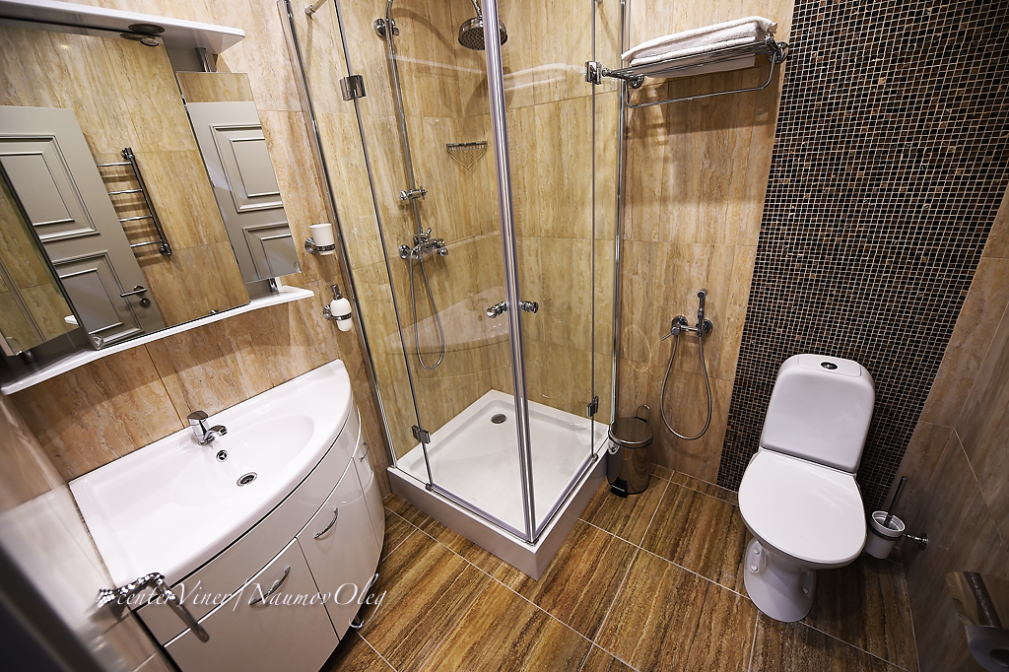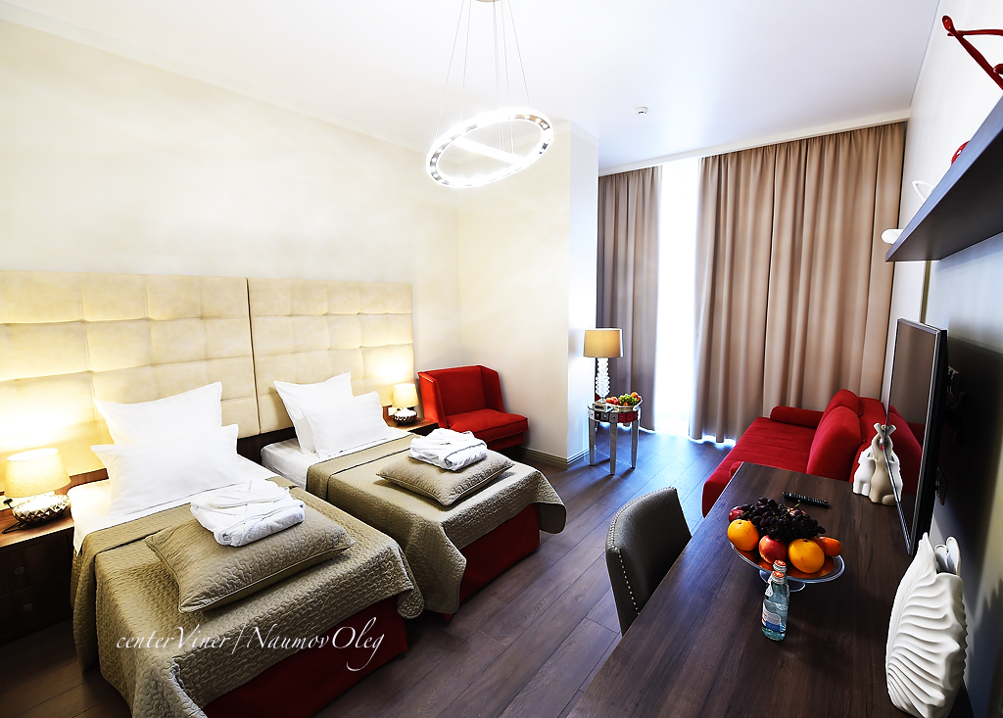

- Costs

All accommodations, meals, training fees, airfares, local transfers, etc., are to be completely paid by participants:

Room Category  27.10.2018 – 05.11.2018 | Rubles,  Per Room (incl. FB & Trainings)
Double Standard, Full Board + Training Fee  1 Adult + 1 Gymnast | 125 000
Triple Standard, Full Board + Training Fee  2 Adults + 1 Gymnast | 155 000
Triple Standard, Full Board + Training Fee  1 Adult + 2 Gymnasts | 190 000

Training fee per gymnast + lunch = 35 000 Rubles

