Approved by E. O. Smirnova,
Director,
Irina Viner-Usmanova’s Rhythmic Gymnastics Centre
OFFICIAL INVITATION & DIRECTIVES

Training Camp
at Irina Viner-Usmanova’s
Rhythmic Gymnastics Centre
- Goals & Objectives

- Promotion of international sport exchange on amateur and professional levels
- Rhythmic gymnasts’ mastery upgrades and progress
- General and special physical training
- Healthy lifestyle
- Mastering and upgrades of R. G. apparatus skills
- Creativity, unconventional way of thinking, musicality, plasticity and artistry by means of classic and modern choreography
- Choreography, various dance styles and plasticity to be learned by young gymnasts
- Selection of talented and promising gymnasts
- Friendly sport exchange

- Dates & Venue

3 – 12 June 2019 - 1st Shift
02 JUN 2019 (arrival & check-in) – 12 JUN 2019 (final day of the training camp/Gala/departure)
03 JUN 2019 – 1st day of the training camp
17 – 26 June 2019 - 2nd Shift
16 JUN 2019 (arrival & check-in) – 26 JUN 2019 (final day of the training camp/Gala/departure)
17 JUN 2019 – 1st day of the training camp
1 – 10 July 2019 - 3rd Shift
30 JUN 2019 (arrival & check-in) – 10 JUL 2019 (final day of the training camp/Gala/departure)
01 JUL 2019 – 1st day of the training camp
15 – 24 July 2019 - 4th Shift
14 JUL 2019 (arrival & check-in) – 24 JUL 2019 (final day of the training camp/Gala/departure)
15 JUL 2019 – 1st day of the training camp
29 July – 7 August 2019 - 5th Shift
28 JUL 2019 (arrival & check-in) – 7 AUG 2019 (final day of the training camp/Gala/departure)
29 JUL 2019 – 1st day of the training camp
12 - 21 August 2019 - 6th Shift
11 AUG 2019 (arrival & check-in) – 21 AUG 2019 (final day of the training camp/Gala/departure)
12 AUG 2019 – 1st day of the training camp

Address: 15 Olympiyskaya Str., Novogorsk District, Khimki, Moscow Region, Russia

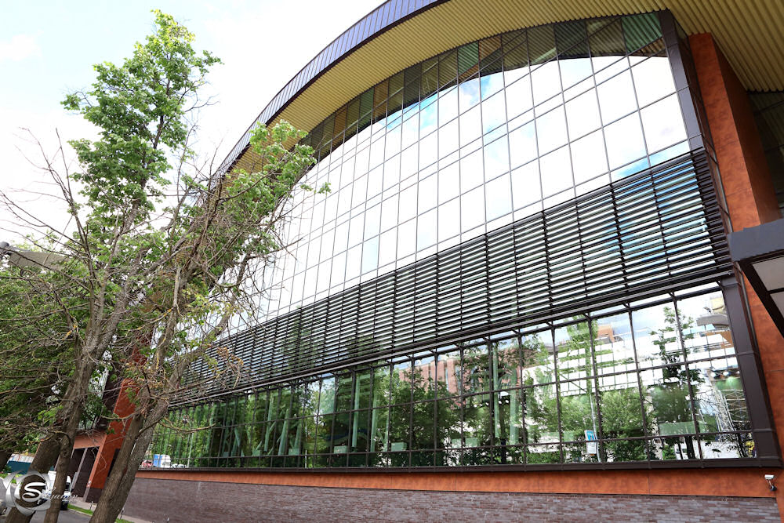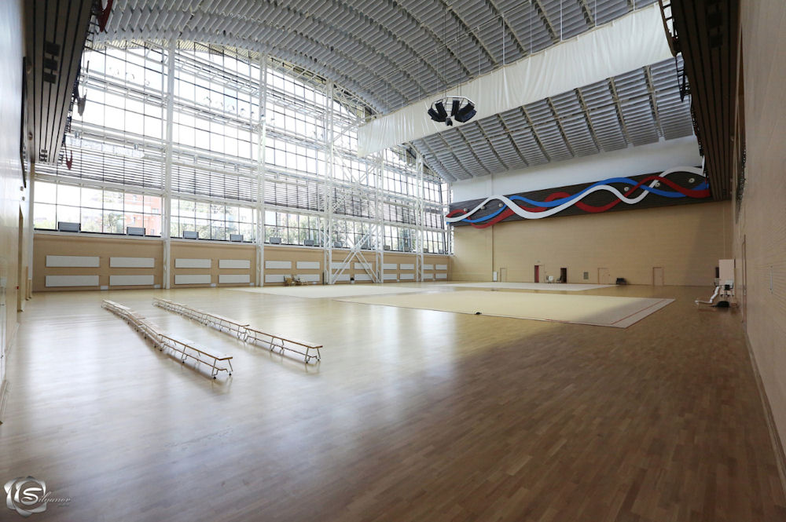
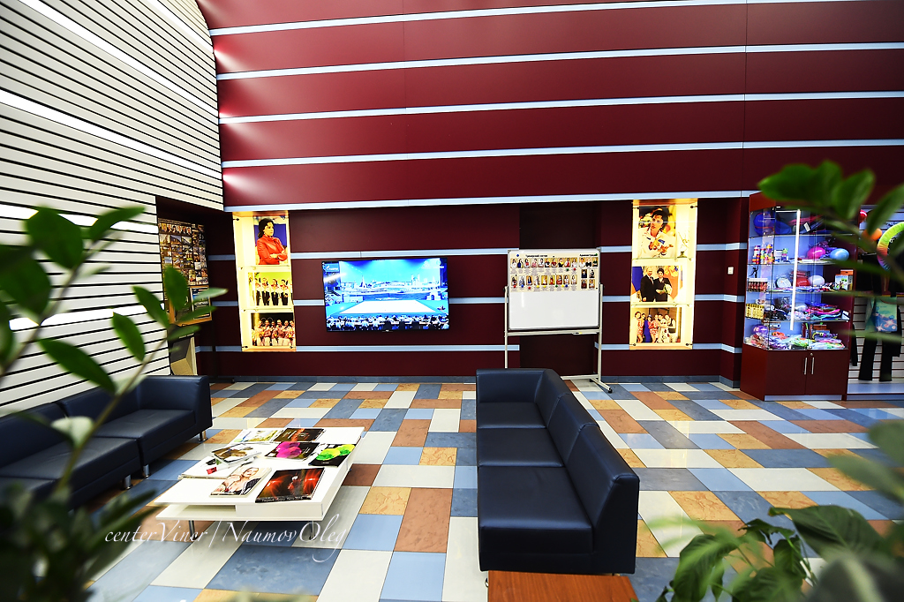

- Coaches (subject to change)

Elena Nefedova – Hon. Coach of Russia, personal coach of the sisters Olga and Ekaterina Kapranova, International Category Judge of the Russian National Team, UEG RG TC Member

Yana Arintseva – Hon. Coach of Russia, National Group Coach, Olympic Coach

Olga Nazarova – Hon. Coach of Russia, the first coach of A. Soldatova & E. Selezneva

Ksenia Dudkina – Hon. Master of Sport, Olympic Champion, Youth Olympic Champion, two-time World and European Champion, three-time Winner of the World Universiade (groups)

Evgenia Gertzikova – Intl. Master of Sport, two-time European Champion, Medalist of the World Championships, National Category Judge

Daria Dubova – Intl. Master of Sport, two-time European Champion, Youth Olympic Champion ‘2014, Winner of the World Cup and Grand Prix Events (groups)

Daria Avtonomova – Intl. Master of Sport, member of Russian National Team, World and European Champion, Winner of the World Universiade

Daria Anenkova – Intl. Master of Sport, two-time Youth Olympic Champion

Daria Kleshcheva – Hon. Master of Sport, Winner of the European Games, World Champion in Groups All-around, member of Russian National Team

Olesya Petrova – Intl. Master of Sport, European Champion in team and apparatus events, Champion of Russia, member of Russian National Team

Maria Titova, Intl. Master of Sports, mult. times medalist, WC & Grand Prix Series & other major intl. events

Karina Katiukhina – Master of Sport, Winner and Medalist of mult. International and National Events, member of Russian National Team

Oleg Antonov – Intl. Master of Sport, five-time Champion of Russia in individual and team events, mult. Winner and Medalist of South Moscow Championships

Dmitry Stepanchikov – graduate of GITIS and L. A. Arts School, Medalist of L. A. World Dance, participant in N. Y. C. Broadway Shows

Victoria Ilyina – Intl. Master of Sport, Youth Olympic Champion, two times European Champion, Winner of mult. World Cup & Grand Prix Events (groups)

Dina Yuldasheva, Choreographer of Irina Viner-Usmanova’s Rhythmic Gymnastics Centre, Top Level Ballet Artist, Russian Ballet Stars Soloist

Ekaterina Ermakova, Choreographer of Irina Viner-Usmanova’s Rhythmic Gymnastics Centre, Top Level Ballet Artist

Ekaterina Uksusnikova, Choreographer of Irina Viner-Usmanova’s Rhythmic Gymnastics Centre, Top Level Ballet Teacher

Ekaterina Ivanova, Master of Sport, Winner of Mult. National and International Events, National RG Judge

Alina Tikhonova, Master of Sport, Winner of Mult. National Events

Nina Kolesnikova, Master of Sport, Winner of Mult. National Events in Groups

Valeria Shkred, Master of Sport, Winner of Mult. National Events

- Program

Two 3-hrs training sessions daily:

- Choreography
- Apparatus Handling, incl. Groups
- Professional Warm-up, General Physical Training
- Stretching & Flexibility
- Dancing Classes
- Acrobatics
- Optional: Making Up Routines, Individual Trainings, Swimming Pool

- Invited Participants

Gymnasts born in 2013 and older, students of youth sport schools, members of sport clubs, amateur teams, etc., with no medical restrictions that may prevent them from rhythmic gymnastics trainings.

All participants will be divided into age groups and subgroups according to their level (approx. 15 – 17 gymnasts per group). Each gymnast will be paid much attention, so the total number of participants is limited. Our task is to meet highest standards of training camps!

- Participation Terms

All gymnasts must have the following:

- Birth Certificate
- Medical / Health / Incident Insurance Policy (copy)
- Doctor’s Approval for Rhythmic Gymnastics Practice
- Gymnastic Leotards, Bandages, etc., incl. GALA costumes (show numbers are welcome!)
- Rubber, Weights, Rubber Mats, etc.
- All Resp. Apparatus, i.e. ropes, hoops, balls, clubs, ribbons
- Music / СD for each routine
- Contract / Payment of resp. training fees and accommodations
- Parents’ Passport Copies

Accommodations:

- The Hotel of Irina Viner-Usmanova’s Rhythmic Gymnastics Centre, 2nd Level of the Building (for accompanied children only).

The number of the hotel rooms is limited (‘first come first served’)!
Only paid entries and accommodations will be accepted!

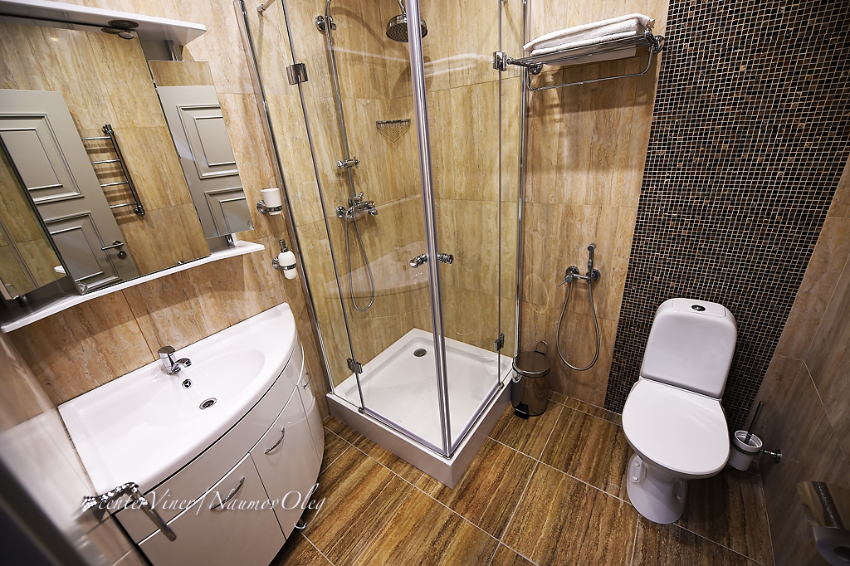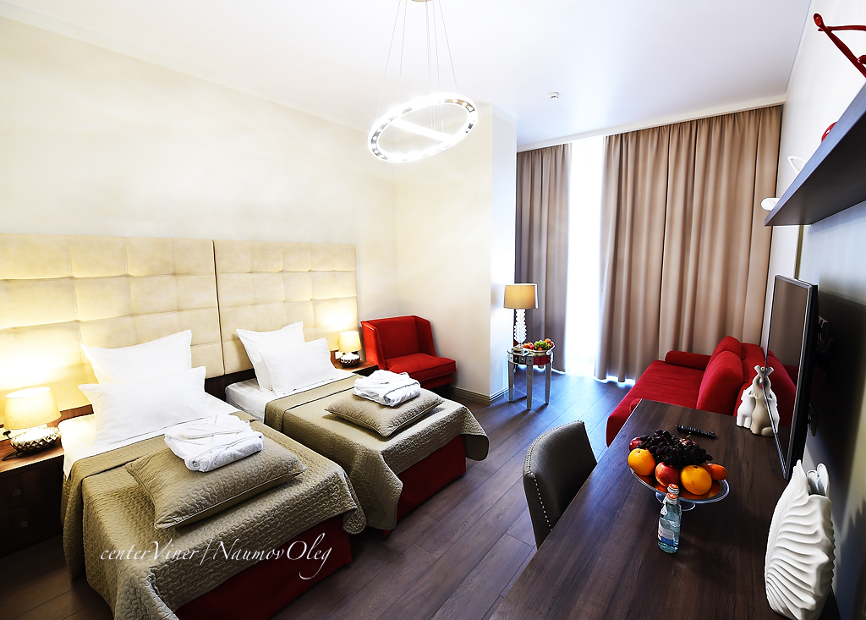

- Costs

All accommodations, meals, training fees, airfares, local transfers, etc., are to be completely paid by participants:

Room Category | Rubles,  Per Room (incl. FB – 10 days)
Triple Standard, Full Board | 130 000
Double Standard, Full Board | 100 000

Training fee per gymnast + lunch = 35 000 Rubles

