Ref. No. 33693 | Approved by E. O. Smirnova,  Director General,  Irina Viner-Usmanova’s Rhythmic Gymnastics Centre
OFFICIAL INVITATION & DIRECTIVES

2019 NOVOGORSK STARLETS
Rhythmic Gymnastics Tournament

Goals & Objectives

- Promotion of international sport exchange on amateur and professional levels
- Rhythmic gymnasts’ mastery upgrades and progress
- General and special physical training
- Healthy lifestyle
- Mastering and upgrades of R. G. apparatus skills
- Creativity, unconventional way of thinking, musicality, plasticity and artistry by means of classic and modern choreography
- Choreography, various dance styles and plasticity to be learned by young gymnasts
- Selection of talented and promising gymnasts
- Friendly sport exchange
- Judges Upgrades

Dates & Venue

24 – 26 May 2019 – 10:00 AM – 20:00 PM

Address:
Irina Viner-Usmanova’s Rhythmic Gymnastics Centre
15 Olympiyskaya Str., Novogorsk District, Khimki, Moscow Region, Russia
Nearest Metro Station: Planernaya,
Shuttle Minibus Route # 981, Nearest Station: Plotina
Tel. +7 925 835 12 57 fsk-novogorsk@mail.ru

FIRST AID & SECURITY SERVICE FOR PARTICIPANTS AND SPECTATORS ARE PROVIDED BY THE ORGANIZING COMMITTEE

ANTI-DOPING REGULATIONS: ACCORDING TO WADA CODE

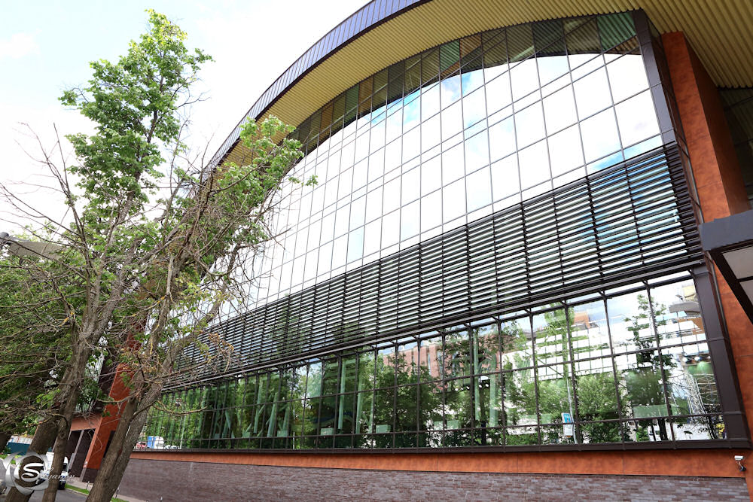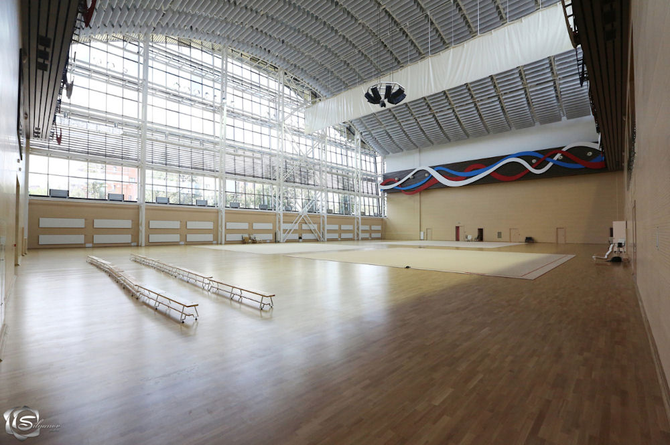
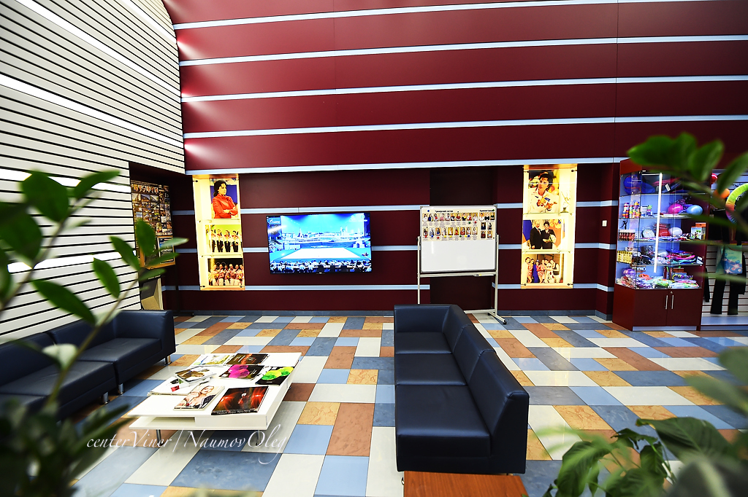

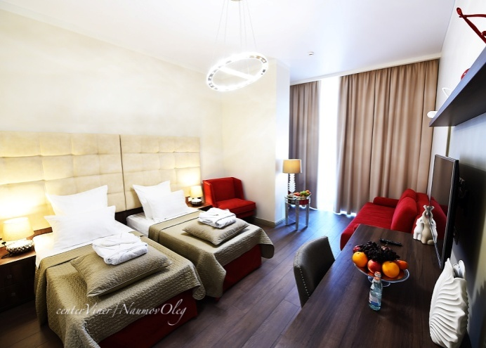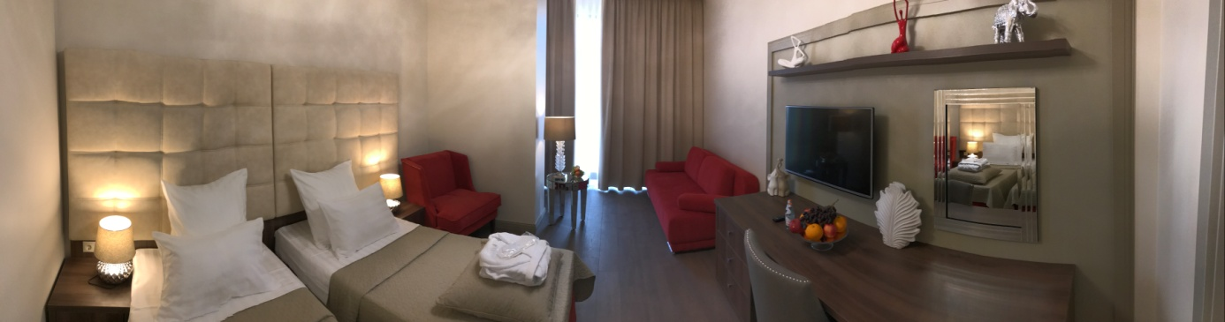
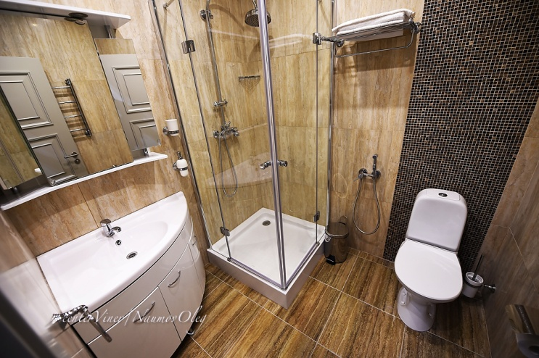
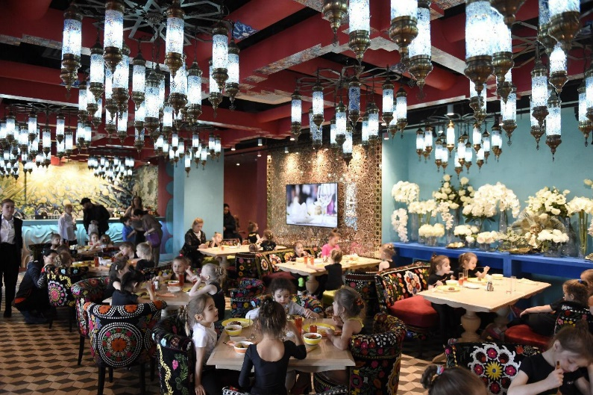

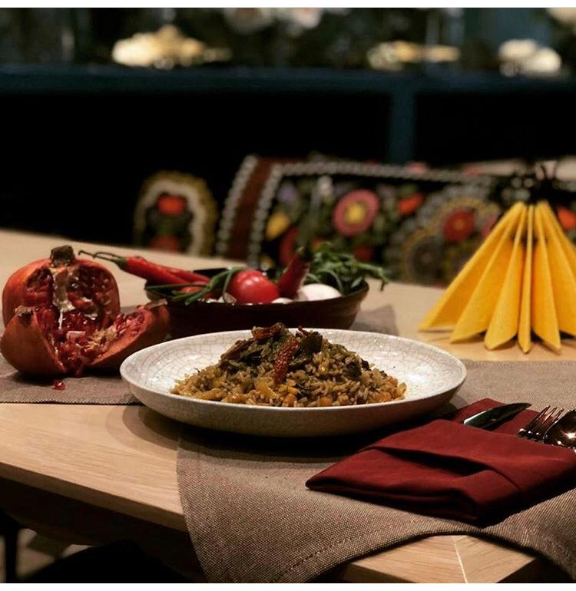

Awards (per each Age Group)

- Cups & Prizes
- Medals
- Diplomas

Invited Participants

Seniors, juniors, pre-juniors, children 6 y. o., students of youth sport schools, members of sport clubs, amateur teams, etc., with no medical restrictions that may prevent them from rhythmic gymnastics:

- Max. 8 individual gymnasts per team
- Max. 5 group gymnasts per team + 1 reserve gymnast
- 1 coach
- 1 judge (obligatory)

Individuals
DOB | Routines | Routines
 | Group А | Group B
2014 | W/a (max. 7 elements)
2013 | W/a | W/a (max. 7 elements)
2012 | W/a  + 1 apparatus by choice | W/a
2011 | W/a  + 1 apparatus by choice | W/a
2010 | W/a  + 2 apparatus by choice | W/a  + 1 apparatus by choice
2009 | W/a  + 3 apparatus by choice | W/a  + 2 apparatus by choice
2008-2007 | W/a  + 3 apparatus by choice | W/a  + 2 apparatus by choice
2004-2006 | 4 apparatus (rope, ball, clubs, ribbon) | 3 apparatus by choice
2003 and older | 4 apparatus (hoop, ball, clubs, ribbon)

Groups

DOB | Program | Routines
2003 and older | Seniors | 5 balls; 3 hoops + 4 clubs
2004-2006 | Juniors | 5 hoops; 5 ribbons
2007-2008 | Pre-Juniors | 5 hoops; 5 ribbons
2008-2009 | Pre-Juniors | W/a; 5 ribbons
2009-2010 | Children | W/a; 5 hoops
2010-2011 | Children | W/a – 1 exercise
2011-2012 | Children | W/a – 1 exercise
2012-2013 | Children | W/a – 1 exercise

The winners in individual program per each age group are to be defined in accordance with the highest score in the competitions.

The final score sheets (electronic format & hard copies) are to be provided within 10 days after the competition.

The competition program may be subject to change/reduction by the Organizers!

All participants will be divided into age groups and subgroups according to their level (the total number of teams is unlimited). Each gymnast will be paid much attention - our task is to meet the highest competitions standards!

Teams with no judges will not be allowed to compete!

Participation Terms

All gymnasts must have the following:

- Passport / Birth Certificate
- Medical / Health / Incident Insurance Policy (copy)
- Doctor’s Approval for Rhythmic Gymnastics Practice
- Gymnastic Leotards, Bandages, etc.
- Rubber, Weights, Rubber Mats, etc.
- All Resp. Apparatus, i.e. ropes, hoops, balls, clubs, ribbons
- Music / СD for each routine
- Contract / Payment of resp. entry fees and accommodations
- Parents’ Passport Copies

For more information please visit our website www.centerviner.com

Inscriptions

Please send your entries before 19 May 2019:
https://www.sportvokrug.ru/cabinet/competitions/5731/

Accommodations

- The Hotel of Irina Viner-Usmanova’s Rhythmic Gymnastics Centre, 2nd Level of the Building (for accompanied children only).

- The number of the hotel rooms is limited (‘first come first served’)! Only paid entries and accommodations will be accepted!

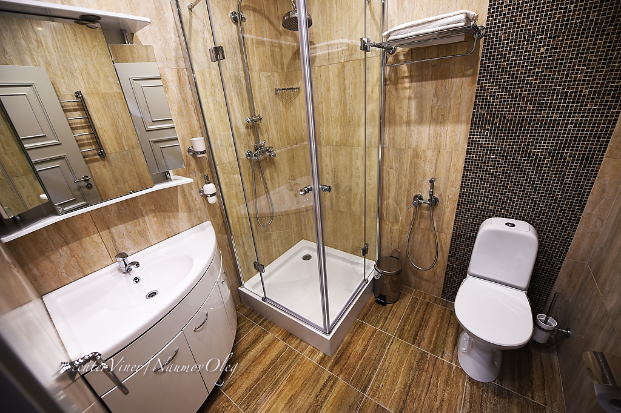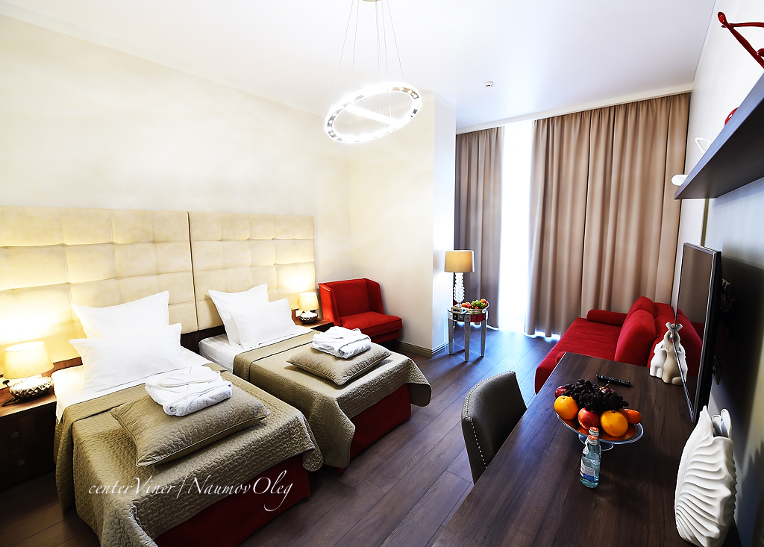

Costs

All accommodations, meals, training fees, airfares, local transfers, etc., are to be completely paid by participants:

Room Category | Rubles,  Per Room Per Day
Single Standard, Breakfast incl. | 10 000
Double Standard, Breakfast incl. | 11 500
Triple Standard, Breakfast incl. | 13 000

Meals

- A cozy Café ‘Khudozhnitsa’ is now located at the Gymnastics Centre
- The café menu offers wide variety of complex meals cooked specially for the Russian National R. G. Team

Entry fees:

- Individuals = 3000 Rubles
- Groups = 9000 Rubles

Jury

- E. Y. Nefedova, FIG Brevet, Head Judge
- O. S. Rastaschenova, National Brevet, Secretary

