Approved by E. O. Smirnova,
Director,
Irina Viner-Usmanova’s Rhythmic Gymnastics Centre

OFFICIAL INVITATION & DIRECTIVES

Training Camp
at Irina Viner-Usmanova’s
Rhythmic Gymnastics Centre

- Goals & Objectives

- Promotion of international sport exchange on amateur and professional levels
- Rhythmic gymnasts’ mastery upgrades and progress
- General and special physical training
- Healthy lifestyle
- Mastering and upgrades of R. G. apparatus skills
- Creativity, unconventional way of thinking, musicality, plasticity and artistry by means of classic and modern choreography
- Choreography, various dance styles and plasticity to be learned by young gymnasts
- Selection of talented and promising gymnasts
- Friendly sport exchange

- Dates & Venue

21 – 29 March 2020
20 MAR 2020 – arrival & check-in
21 MAR 2020 – 1st day of the training camp
29 MAR 2020 – the final day of the training camp & departure

Address: 15 Olympiyskaya Str., Novogorsk District, Khimki, Moscow Region, Russia

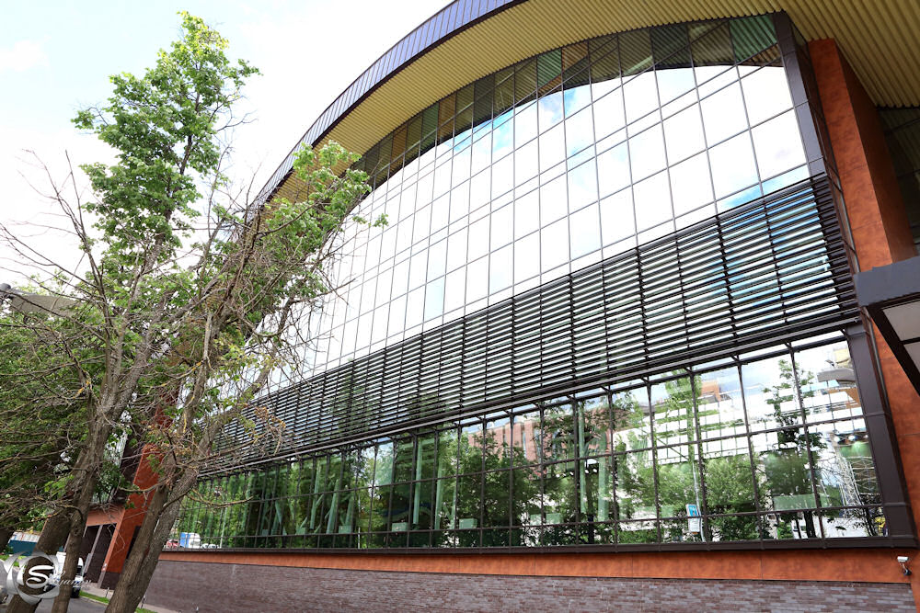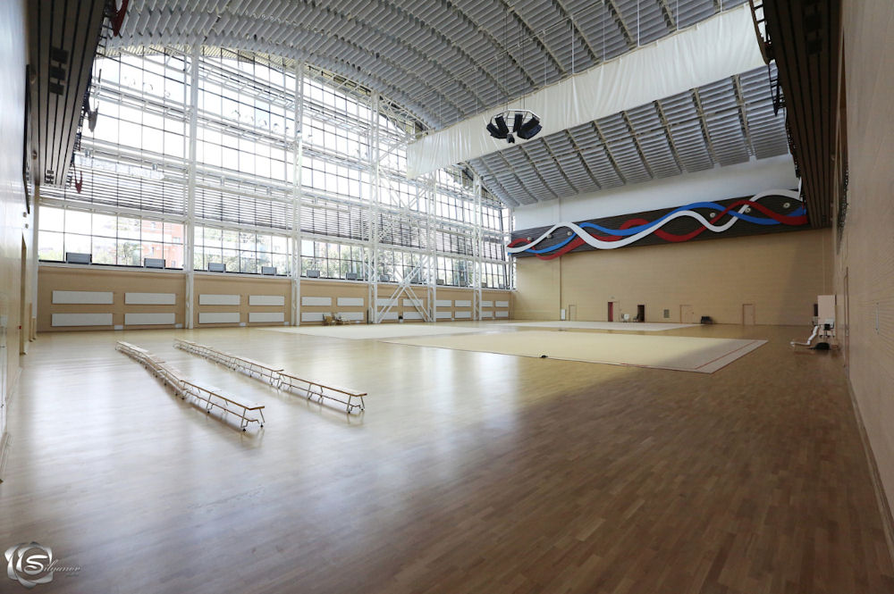
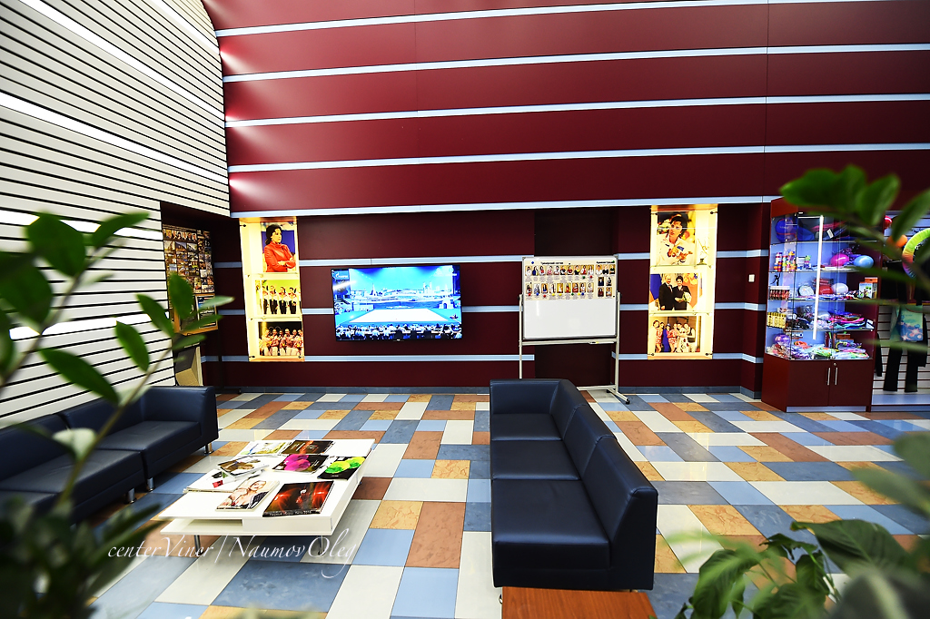

- Coaches (subject to change)

Yana Arintseva – Hon. Coach of Russia, National Group Coach, Olympic Coach

Evgenia Gertzikova – Intl. Master of Sport, two-time European Champion, Medalist of the World Championships, National Category Judge

Zlata Tulubaeva- –Master of Sport of USSR, eleven-time Champion of Kirghizia, International Category Judge

Daria Avtonomova – Intl. Master of Sport, member of Russian National Team, World and European Champion, Winner of the World Universiade

Olesya Petrova – Intl. Master of Sport, European Champion in team and apparatus events, Champion of Russia, member of Russian National Team

Maria Titova- Intl. Master of Sports, mult. times medalist, WC & Grand Prix Series & other major intl. events

Daria Dubova – Intl. Master of Sport, two-time European Champion, Youth Olympic Champion ‘2014, Winner of the World Cup and Grand Prix Events (groups)

Victoria Ilyina – Intl. Master of Sport, Youth Olympic Champion, two times European Champion, Winner of mult. World Cup & Grand Prix Events (groups)

Olga Rastaschenova – Intl. Master of Sport, four times Champion of Russia, Winner of Russian Cup (groups)

Veronika Rudycheva – Intl. Master of Sport, Champion of Russia (group), Winner of mult. World Cups

Irina Koshevaya –Master of Sport of Russia, High Category Judge, classman of physical culture, National Category Judge

Nina Kolesnikova- Master of Sport of Russia, finalist of Championship of Russia, Winner of Russian competitions (groups)

Karina Katiukhina – Master of Sport of Russia, Winner and Medalist of mult. International and National Events (groups), winner of Eurasian Games

Polina Gelasimova – Master of Sport of Russia, Winner of Championship of Russia, Winner of mult. World Cup & Grand Prix Events (groups)

Alevtina Sonova – Master of Sport of Russia, Medalist of mult. World Cup & Grand Prix Events (groups)

Nataliya Guschina – Master of Sport of Russia, Winner and Medalist of mult. Moscow Championships (individual and groups)

Ekaterina Zinoveva –Master of Sport, Medalist of Russian Championships, Finalist of World fitness-aerobics championship

Anna Dunaeva –Master of Sport, Winner and Medalist of mult. International and National Events

Valeria Shkred- Master of Sport, Winner of Mult. National Events

Angelina Bozhenova –Master of Sport, Winner and Medalist of mult. National Events

Pavel Shlein –Master of Sport in Gymnastics and Trampolining, Winner and Medalist of Russian Championship in Gymnastics and Trampolining, Winner of International Tournaments and Summer Spartakiada

Dmitry Stepanchikov – graduate of GITIS and L. A. Arts School, Medalist of L. A. World Dance, participant in N. Y. C. Broadway Shows

Ekaterina Ermakova, Choreographer of Irina Viner-Usmanova’s Rhythmic Gymnastics Centre, Top Level Ballet Artist

- Program

Two 3-hrs training sessions daily:

- Choreography
- Apparatus Handling, incl. Groups
- Professional Warm-up, General Physical Training
- Stretching & Flexibility
- Dancing Classes
- Acrobatics
- Optional: Making Up Routines, Individual Trainings, Swimming Pool

- Invited Participants

Gymnasts born in 2014 and older, students of youth sport schools, members of sport clubs, amateur teams, etc., with no medical restrictions that may prevent them from rhythmic gymnastics trainings.

All participants will be divided into age groups and subgroups according to their level (approx. 15 – 17 gymnasts per group). Each gymnast will be paid much attention, so the total number of participants is limited. Our task is to meet highest standards of training camps!

- Participation Terms

All gymnasts must have the following:

- Birth Certificate
- Medical / Health / Incident Insurance Policy (copy)
- Doctor’s Approval for Rhythmic Gymnastics Practice
- Gymnastic Leotards, Bandages, etc., incl. GALA costumes (show numbers are welcome!)
- Rubber, Weights, Rubber Mats, etc.
- All Resp. Apparatus, i.e. ropes, hoops, balls, clubs, ribbons
- Music / СD for each routine
- Contract / Payment of resp. training fees and accommodations
- Parents’ Passport Copies

Accommodations:

- The Hotel of Irina Viner-Usmanova’s Rhythmic Gymnastics Centre w/swimming pool and cafe, 2nd Level of the Building (for accompanied children only).

The number of the hotel rooms is limited (‘first come first served’)!
Only paid entries and accommodations will be accepted!

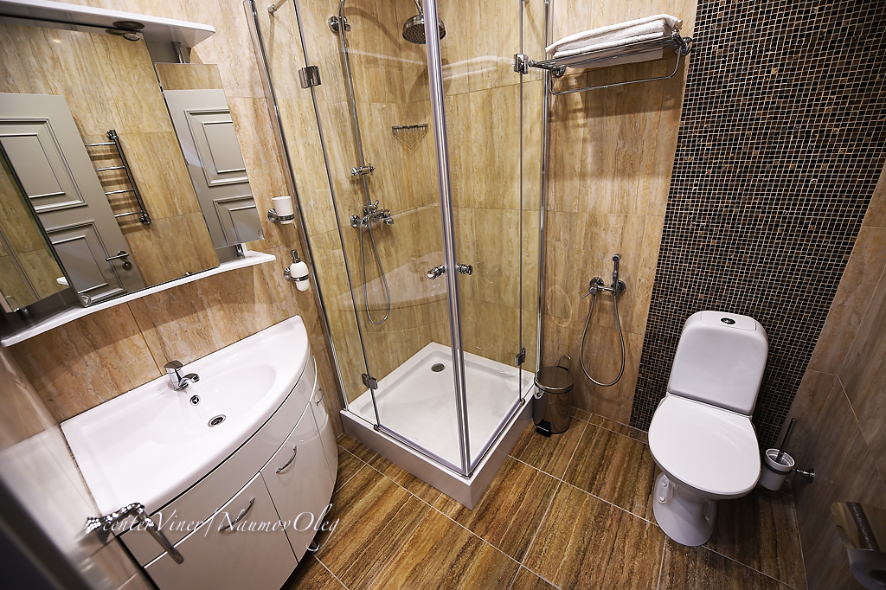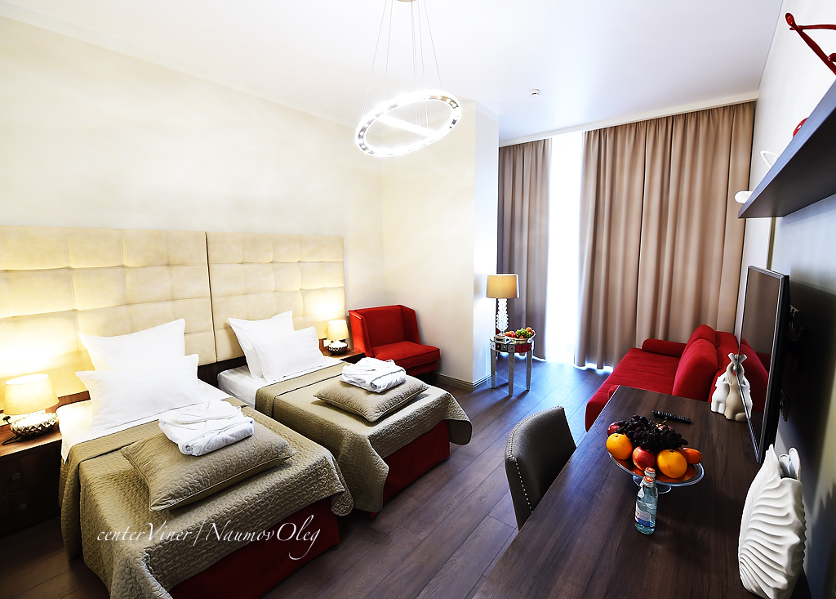

- Costs

All accommodations, meals, training fees, airfares, local transfers, etc., are to be completely paid by participants:

Room Category  (20 – 29 MAR 2020) | Rubles,  Per Room (incl. FB – 9 days)
Triple Standard, Full Board | 135 000
Double Standard, Full Board | 99 000

Training fee per gymnast + lunch = 35 000 Rubles

======================================================================

TO REGISTER FOR THE ABOVE TRAINING CAMP PLEASE CONTACT:

www.sportvokrug.ru

